Title:

Antenatal origins of chronic disease – linking antenatal fetal size to chronic disease outcomes in children and young adults

Researcher:

Mr Anthony Chapman

Contact details:

Room 244

Meston Building

University of Aberdeen

Aberdeen AB24 3UE

Supervisors:

Dr Steve Turner

Dr Wei Pang

Dr Lorna Aucott

**Abstract**

Incurable chronic conditions in childhood which persist into adulthood and common and lead to considerable morbidity and ultimately mortality. Chronic conditions such as asthma, insulin dependent diabetes mellitus (IDDM), epilepsy and attention deficit hyperactivity disorder (ADHD) can be managed with treatment but prevention, as opposed to cure, offers the best promise of reducing prevalence of these diseases. Better understanding of the early origins of these conditions is required before targeted preventative interventions are introduced, and there is evidence that antenatal factors are important determinants of chronic illness in post natal life. Our group has for the first time related antenatal fetal ultrasound measurements to risk for asthma and also to glycosylated haemoglobin (a biomarker for IDDM). In this project we will extend our findings to a larger and older cohort and also explore associations between fetal measurements and epilepsy and ADHD. The overarching hypothesis is that reduced fetal size is an indicator for many different chronic conditions. The student will (i) link fetal and maternal details held on the Aberdeen Maternity and Neonatal Databank to routinely acquired prescribing of asthma medication and hospital admission data held by the Scottish Government and (ii) describe associations between fetal size and growth to IDDM, ADHD and epilepsy identified from prescribing and admission data. The results will be novel and generate a substantial advance in the understanding of fetal origins of chronic disease.

**Background**

There are several common chronic conditions of childhood which persist into adulthood of which asthma is one example. Asthma affects 5.4 million people in the UK and costs the NHS £1 billion per annum1. Although asthma symptoms can be palliated with inhaled steroids, there is no cure. Prevention is the most promising method for reducing the burden of asthma in Britain but better understanding of asthma pathogenesis (and a method to identify at risk individuals) is required. What is understood is that events in early life are important to asthma outcome in both childhood and adulthood.

A number of observations point to important antenatal/perinatal influences on the development of asthma: (i) Reduced birth weight is associated with adult asthma suggesting that fetal growth is important to asthma aetiology2. (ii) Obstructed lung function, a feature of asthma, is present from one month of age in individuals who later develop asthma3 and (iii) obstructed lung function persists from early infancy to at least 22 years of age4. The “fetal origins” of chronic disease hypothesis was first described in 19855 and suggested that physiological adaptations *in utero* alter risk for future morbidity. Only very recently has fetal ultrasound measurement been used as a surrogate for fetal well-being *in utero* and there is now evidence that small fetal size is associated with increased risk for morbidity in support of the fetal origins hypothesis. What is not know is whether small fetal size is the cause is merely associated with increased risk for NCD but in the first instance any association between fetal measurements and morbidity needs to be thoroughly explored.

Ours was the first group in the world to relate fetal ultrasound measurements to asthma outcomes6-8. We used fetal measurements as a surrogate for fetal well-being in a birth cohort of 2000 individuals designed to relate early life exposures to asthma outcomes. We observed an association between persistently reduced fetal size from ten weeks gestation and increased asthma and reduced lung function in five6 and ten year old children7. We also observed how maternal dietary exposures6 and smoking8 may affect fetal growth at different gestations and these findings may be useful for future interventions. Subsequently our results have been replicated in two cohorts9-10 but not a third11. Although the study which found no association between fetal size and respiratory outcomes may be flawed due to imprecise gestational estimate12, our results require confirmation in a population which is larger and has been followed up beyond childhood.

In addition to asthma, there are other chronic conditions where antenatal growth may be important to causation and these include insulin dependent diabetes mellitus (IDDM), epilepsy and attention deficit hyperactivity disorder (ADHD). In a paper currently in submission we have demonstrated an association between first trimester fetal size and a biomarker for poor IDDM control (glycosylated haemoglobin) and this is proof of concept that fetal size may be an indicator for IDDM Although there are no studies linking fetal size to epilepsy and ADHD, in one cohort fetal head circumference has been linked to language difficulties13 which can be a surrogate for abnormal neurodevelopmental development. Given the increasing prevalence of IDDM, ADHD and the relatively high prevalence of epilepsy (1:1000) we will generalise associations we have seen between fetal growth and asthma to these other conditions.

One method to relate fetal ultrasound measurements to asthma and other non-communicable diseases would be to recruit an large birth cohort and follow this up for 25 years. An alternative, and our strategy, is to use routinely acquired fetal ultrasound measurements in Aberdeen, which have been collected since 1985, and link these to routinely acquired prescribing records in 2012. Individuals with asthma, IDDM, epilepsy and ADHD are treated with condition-specific medications and thus can be reliably identified. A smaller number of individuals with asthma, IDDM and epilepsy can also be identified from hospital admission records. The benefits of this approach, compared to recruiting a new birth cohort in 2012, are (i) results will be available in two-three years and not the 25-30 years it would take to recruit the birth cohort and for the individuals to reach adulthood (ii) the cost is a small fraction of the cost of a birth cohort (iii) drop out of a birth cohort is usually 50% over 10-15 years but our approach will endure that fetal scan measurements can be lined to outcomes individuals still living in Scotland (likely to be 80-90%).

**Hypotheses**

1. Reduced antenatal fetal size is an indicator for asthma (as evidenced by prescription of inhaled corticosteroid).
2. Reduced antenatal fetal size and growth is an indicator for type I diabetes (as evidenced by prescription of insulin).
3. Reduced second trimester fetal head circumference fetal size and growth between second trimester and birth is an indicator for epilepsy (as evidenced by prescription of anticonvulsants).
4. Reduced second trimester fetal head circumference fetal size and growth between second trimester and birth is an indicator for ADHD (as evidenced by prescription of dexamphetamine).

**Aims**

The aim of this project is to link fetal size and growth to non-communicable diseases in children and young adults .

1. To link fetal and maternal characteristics to outcomes in the form of dispensed medications to the specified conditions
2. To identify the key timing of growth changes relating fetal measurements to the specified conditions.
3. To describe the sensitivity and specificity of fetal measurements for predicting adult asthma, IDDM, epilepsy and ADHD.

**Plan of investigation**

*Study design.* This will be a whole population cohort study. Fetal measurements held on the Aberdeen Maternity and Neonatal Databank (AMND) will be linked to prescribing data held by the Scottish Government’s Information Services Division (ISD). ISD will also provide hospital admission details (from SMR01) which will allow hospitalisation for asthma, epilepsy and IDDM to be linked to fetal measurements. Every individual in Scotland has a community health index (CHI) number and this unique identifier means that Scotland is one of the few places in the world where the proposed linkage can take place.

*Fetal measurements.* In 1985, fetal ultrasound scans became part of routine antenatal care in Aberdeen. Figure 1 shows the proportion of pregnancies delivering between 1985 and 2011 where scan data are available. Fetal measurements were entered into maternal case notes and we have already demonstrated that fetal measurements can be retrieved from paper records, entered onto an electronic database and linked to post natal outcomes6-8. The first trimester measurement will be crown rump length, and second trimester measurements will be head circumference, femur length and abdominal girth. Fetal size, i.e. crown rump length, biparietal diameter and femur length, will be expressed as an absolute measurement and also as a z score as previously6. Gestation at scan will be recorded. We have described the strengths and limitations of using fetal measurements as a surrogate for fetal wellbeing14. In one third of pregnancies, where maternal dates of last menstrual period (LMP) are uncertain, fetal gestation is determined by first trimester scan. This is an important potential confounder which we acknowledge and can address by subgroup analysis of those individuals whose maternal LMP is certain but our primary fetal measurements will be from the second trimester since we know that the gestation at these scans are more reliable than for first trimester scan.

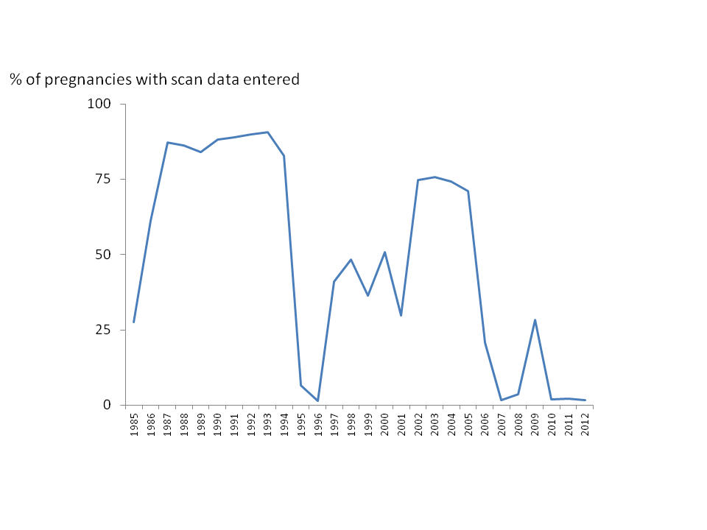

Figure 1. Proportion of pregnancies with scan data by year of delivery

*AMND*. The AMND was established in the 1950 and holds details of pregnancy, labour and delivery for each infant born in Aberdeen (http://www.abdn.ac.uk/amnd/). Permission will be sought from the AMND steering committee to access the following data from singleton term pregnancies: infant CHI number, gender, first and second trimester measurements and gestation at measurement, gestation at birth, and birth measurements (i.e. crown heel length, head circumference and birth weight), maternal age (decimal), maternal deprivation index (Carstairs), maternal smoking status, maternal chronic illness (defined as receipt of medications specific for asthma, IDDM, epilepsy and ADHD), maternal weight and height, Pregnancies where more than 10 scans were attended will be excluded; we already know that only 10% of mothers have more than five scans during a single pregnancy. Individuals with severe congenital anomalies will be excluded, e.g. trachea-oesophageal fistula, tetralogy of Fallot.

*Information Services Division (ISD)*. ISD holds details of primary care prescriptions issued in Scotland since April 2009 and we know that 96% of prescriptions in Scotland have the patient’s CHI number. Our primary outcome will be prescription of disease-specific medication (*see addendum for specific definitions to be used*). The secondary outcomes will be admission to hospital for asthma, epilepsy and IDDM. Additionally, and to make best use of the data collected, we will determine indices of asthma control (as evidenced by number of reliever medication inhaler/year, also see addendum), asthma exacerbation (as evidenced by prednisolone use/year) and asthma severity (as evidenced by British Thoracic Society treatment step ranging from 1 to 5 where treatment is stepped up and down according to symptoms and also age, http://www.sign.ac.uk/pdf/qrg101.pdf). The combined database containing fetal and maternal details will be merged with the ISD database holding prescribing and admission data (a process called “cross-warehouse analysis”) within the ISD safe haven. To assure confidentiality, the CHI will then be stripped out of the database, rows sorted randomly and the database returned to Aberdeen through nhs.net. The database will be stored in the Aberdeen safe haven.

Analysis.  The primary outcome will be receipt of >1 prescription of disease specific medication over any 6 month period in 2012.  Data collected on all participants will be described using number or percentage in each category or mean and standard deviation for normally distributed continuous variables (or median and inter-quartile range if skewed).  Logistic regression will be use to relate outcome to absolute fetal size with adjustment for gestation at scan and covariates including gender, maternal smoking, deprivation and maternal asthma. We will use mixed linear models to study the relationship between changes in fetal size and outcomes; this approach considers the co-linearity of fetal measurements within an individual, provides a magnitude of association between change in growth and risk for outcomes and increase the power of the analysis by imputing missing variables. We will explore the potential for applying Frequentist and Bayesian models to the dataset. A receiver operated characteristic curve will be used to determine the CRL z score with best sensitivity and specificity for outcomes. For asthma severity (measured on ordinal scale of 1-5) we will use ordinal logistic regression.

*Power*.This calculation is based on asthma since this is where we have robust data to inform a power calculation.  Assuming 5000 deliveries per year and scans available between 1985 and 1996, there will be as many as 60,000 scan results to enter into the database; our experience is that the actual figure will be closer to 55,000 as some mothers do not have ultrasound scans and some scan results will be misplaced.  On a *pro rata* basis we will expect 20,350 (37%) to have persistent high growth, 16,500 (30%) persistent low growth, 11,000 (20%) growth acceleration and 7,700 (14%) growth deceleration between the first and second trimesters8.  We shall assume that the prevalence of asthma (as evidenced by receipt of more than one inhaled corticosteroid prescription in 6 months) is 10% in the persistently low group and 5% in the persistently high group. Using a two group chi-squared test with a 1% two-sided significance level will have greater than 90% power to detect the difference between a Group 1 proportion of 0.100 (persistent low group) and a Group 2 proportion of 0.050 (persistent high group) (odds ratio of 0.474) suggests samples of at least 824 in each group indicating that the sample sizes of 16500 and 20350, respectively will be sufficient.

**References**

1. Asthma UK. <http://www.asthma.org.uk/news-centre/facts-for-journalists/>
2. Shaheen et al. Birth weight, body mass index and asthma and young adults. Thorax 1999;54:396-402
3. **Turner SW**, et al. The relationship between infant airway function, childhood airway responsiveness and asthma. Am J Respir Crit Care Med 2004;169:921-927
4. Stern DA. Poor airway function in early infancy and lung function by age 22 years: a non-selective longitudinal cohort study. Lancet [2007; 370: 758–764.](http://www.ncbi.nlm.nih.gov/entrez/eutils/elink.fcgi?dbfrom=pubmed&retmode=ref&cmd=prlinks&id=17765525)
5. Barker DJ. Fetal origins of coronary heart disease. Br Med J 1995;311:171–174
6. **Turner SW**, et al. Associations between fetal size, maternal α-tocopherol and childhood asthma. Thorax 2010;65:391-397
7. **Turner S,** et al. First and second trimester fetal size and asthma outcomes at age ten years. Am J Respir Crit Care Med 2011; 184:407-413
8. Prabhu N, et al. First trimester maternal smoking habits and fetal growth. Thorax 2010;65:235-40

9. Pike KC, et al. Patterns of fetal and infant growth are related to atopy and wheezing disorders at age 3 years. Thorax 2010;65:1099–1106

10.Hall G, et al. Increased fetal growth protects against early wheeze, airway hyper-responsiveness (AHR) and current asthma in early mid-childhood: Results from the Raine birth cohort (abstract). Eur Respir J 2011;38:S569

11 Sonnenschein-van der Voort AM. Fetal and Infant Growth and Asthma Symptoms in Preschool Children: The Generation R Study Am J Respir Crit Care Med 2012; 185: 731-737

12.**Turner S, Devereux G**. Fetal Ultrasound: Shedding Light or Casting Shadows on the Fetal Origins of Airway Disease. Am J Respir Crit Care Med 2012 185: 694-695

13. RAINE fetal measurements and language delay

14.**Turner S**. Perinatal Programming of Childhood Asthma: Early Fetal Size, Growth Trajectory during Infancy, and Childhood Asthma Outcomes. Clin Dev Immunol 2012; 2012, Article ID 962923

Time Line:

Summer 2016, linkage pan, governance agreed and linkage completed. July 2016, analyses undertaken in systematic manner, e.g. fetal size/growth and asthma, fetal size/growth and asthma admissions/severity, fetal size/growth and IDDM, fetal size/growth and IDDM admissions, etc. Oct 2016-Feb 2017 publish results and write up thesis.